Patent Draft for E-Portal for Case Management and Legal Proceedings Facilitation

APPLICANT(S)

Name in Full | Nationality | Country of Residence | Address of the Applicant
Akash Tiwari | Indian | India | KIET Group of Institutions, Ghaziabad, Uttar Pradesh 201206
Akshat Jain | Indian | India | KIET Group of Institutions, Ghaziabad, Uttar Pradesh 201206.
Aaditiya Tyagi | Indian | India | KIET Group of Institutions, Ghaziabad, Uttar Pradesh 201206
Ankit Chaudhary | Indian | India | KIET Group of Institutions, Ghaziabad, Uttar Pradesh 201206.

1.Proposed Title
E-Portal for Case Management Hearing and Facilitation of Legal Proceedings.

2.Field of Invention
This invention falls under digital case management and legal proceedings. In this regard, it deals with an electronic portal designed to automate the management of court hearings, case filing, document submission, status tracking, and role-based access integrated for litigants. lawyers, judges, court staff, and administrators.
3.Background (Reason to Work)
The courts use mainly manual case management. Those include issues like delay and back-log, where access to justice seems not guaranteed. All these are manifestations of paper-work, in-person interaction, and errors made in the tracking of the case status. Such manual processes decrease the accessibility of litigant justice since a litigant is at the inevitable mercy of complexity about managing cases. An automated, transparent, and accessible digital solution is necessary to address these issues. This invention shall try to make the entire process of case management streamlined because it digitizes it while being more efficient, transparent, and delay-free, hence reaching justice quicker and easier. The system would also provide real-time updates and improve the overall flow of information, ensuring that all involved parties, including lawyers, clients, and court staff, can collaborate more effectively. By minimizing human errors and reducing the dependence on physical documents, this solution could revolutionize the judicial system, offering both speed and accuracy.

4.Differentiate with other works
Unlike any other case management system, this innovation is an all-in-one solution. The automatically created workflow forms shall address the role of the litigant, lawyer, judge, court staff, and administrator. This innovation contains the following:
This system includes a user verification system to ensure proper role-based access. It allows submission and tracking of cases with the capability to upload documents. A pre-hearing settlement option enables discussion of the case before the actual hearing process. The system provides automatic alerts for schedules and updates related to hearings. It incorporates data analysis tools to generate performance reports and identify trends. Strong security measures, including encryption, audit trails, and adherence to legal requirements, ensure the safety and confidentiality of data. The level of integration, automation, and security offered by this system sets it apart in the marketplace.

5.Objectives
Case management would be automated. The backlog and the delays would be discontinued. Role-based access to the system would increase transparency and security. Automated alerts and notifications would be triggered for any hearing schedule and status change of a case. Settlement of cases would occur before formal hearings. The system would enable data-driven decisions through performance monitoring and analytics tools.

6.Drawing
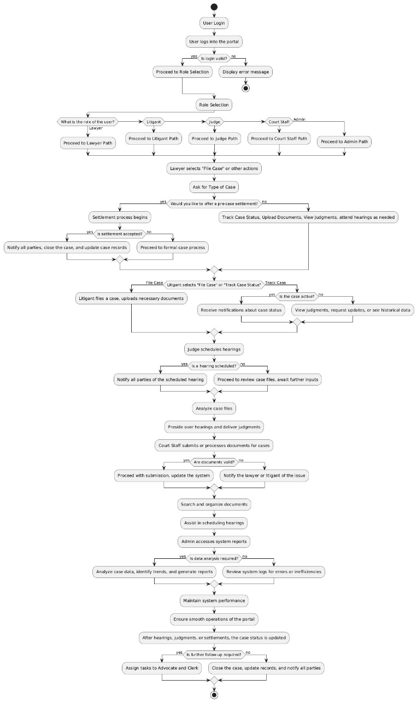
7.Cases (New/Innovative concepts)
Digital case management system with automatic workflows in filing cases, fixing for hearings, and tracking of documents.
User verification system where access is allowed with the specified roles of a litigant, lawyer, judge, clerk, or administrator for security and confidentiality.
Automated alerts and notices to both parties for a status update on the case, as well as the scheduled hearing date.
A pre-hearing settlement feature that will enable parties to seek solutions outside the courtroom prior to formal court hearings.
Analytics and reporting tools to allow data tracking of case trends and performance decisions.

8.Apparatus/Technology Used (hardware / Software)
Hardware:
Servers for hosting the platform and storing case data. User devices (computers, mobile phones) for accessing the system.
Software:
A web-based platform made with the latest technologies, such as React and Node.js. A database management system, for example, MySQL or PostgreSQL, for user and case data storage. Security protocols on data transmission via SSL/TLS encryption and access controls based on roles.

9.Abstarct
The present invention lies in an automated e-portal for case management and a facilitation tool in legal proceedings. Digitizing the traditional case management system, the platform makes it easy to interact with litigants, lawyers, judges, court staff, and administrators based on a role-based access structure, thereby making it easy to manage such processes as filling in cases, submission of documents, scheduling of hearings, and tracking of cases. The portal comes with automated warnings, settlement modes, and analytical datasets that will promote efficiency and proper decision making while upholding transparency. The system is highly secure to respect user data and thus adhere to the regulations in place.
10. End Users
Litigants: Filer persons; persons for whom cases are filed.
Lawyers: Practicing legal professionals who represent clients.
Judicial Officers: People responsible for delivering judgments.
Court Staff: Administrative people who take care of case documents, schedules, among other tasks.

11.Advantage
Efficiency: Automates case backlog and reduces human error occurrence.
Accessibility: Online portal facilitates remote access to case status and documents.
Transparency: Instant updates help keep all parties informed regarding the case status.
Data-Driven Decision Making: Making informed decisions through case trends analysis tools.
Security: Encryption and role-based access controls secure data.

12.Conclusion/Summary
The case management process receives a massive innovation in the form of the proposed e-portal. Key workflows are automated, coupled with heightened security on the portal, along with role-based access, to ease transparency and efficiency in the legal proceeding process. Case filing and scheduling of hearings in court becomes streamlined, with minimal delays, and updates are timely for the parties concerned. It further equips inherent data analysis tools and settlement options for managing all the inefficiencies that were inherent within traditional court systems. This patent has been able to protect an important step forward in legal technology, enhancing access to justice and decision-making processes.

